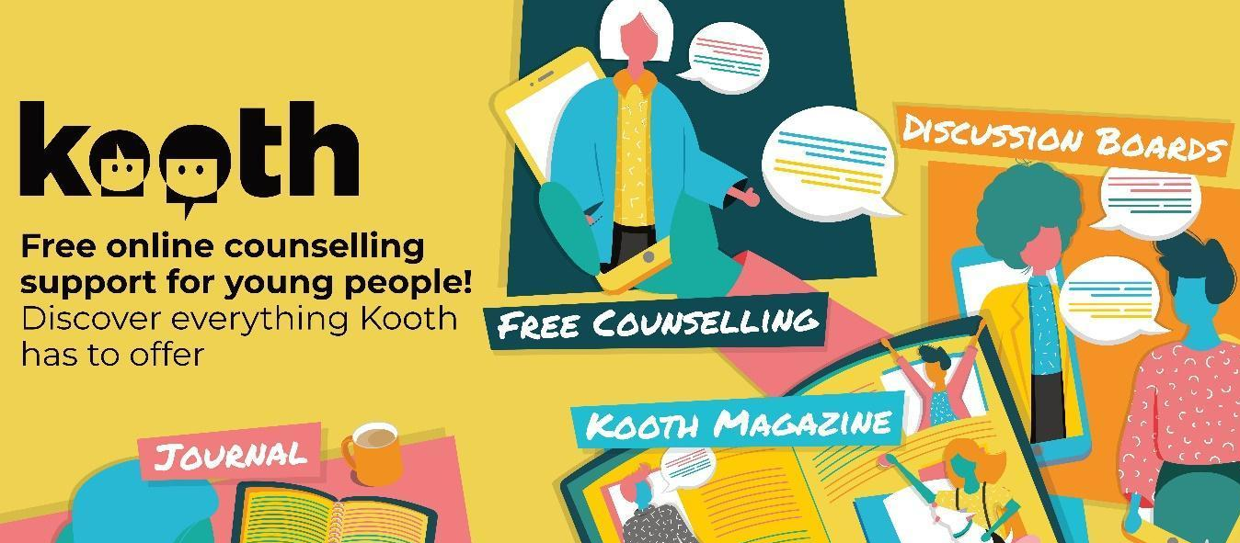

Kooth Online Emotional Wellbeing & Mental Health Service for 10 – 18 years

Kooth is working with Aberdeenshire Council to launch our Kooth online emotional wellbeing & mental health service for young people in the area from 21st June 2021.

Kooth is a free online counselling and emotional well-being support service providing young people aged 10-18 years in many areas across the UK with a safe and secure means of accessing support with their emotional health and wellbeing needs from a professional team of qualified counsellors, as well as providing access to many self-help tools and content.

Kooth is a well-established, award winning online counselling service and is accredited by The British Association of Psychotherapy and Counselling (BACP). Young people can access this service anonymously by signing onto the Kooth site. Kooth provides unique out of office hours’ provision and is open 7 days per week, 365 days a year with 1:1 support being available from noon until 10pm weekdays and from 6pm until 10pm on Saturday and Sundays. Kooth provides added value with moderated, scheduled forums and self-help articles (many written by service users) to provide peer led and self-help support 24/7.

To find out more about Kooth you can watch a video Kooth Video
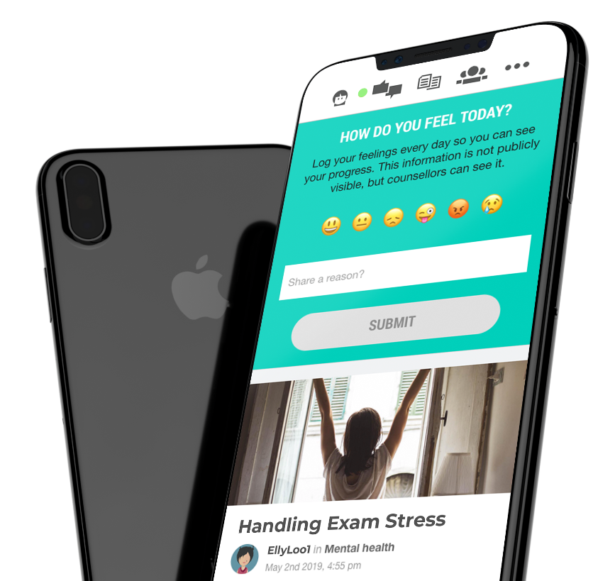
Please do not hesitate to contact Kooth in Aberdeenshire with any queries via ksmith@kooth.com aberdeenshire@kooth.com

