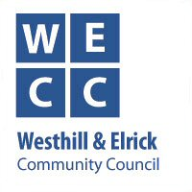
Westhill & Elrick Community Council
10th December Meeting - Key Points Summary

Xmas is coming! – and we are all eagerly looking forward to some Xmas cheer (Covid precautions permitting). Since our last meeting volunteers have been busy fixing up the Xmas street lights and erecting and decorating the Xmas tree at the Shopping Centre.

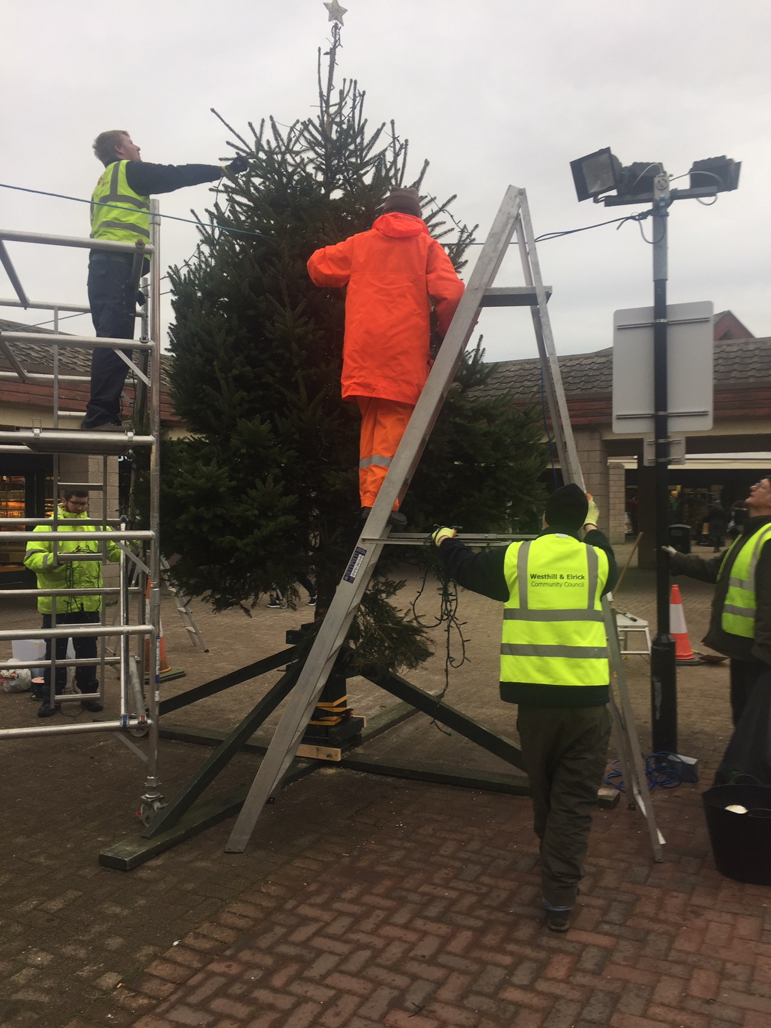
Our thanks to Dunecht Estate for their gift of the tree again and to staff from FES Ltd and members of the Westhill Mens’ Shed who helped us erect it and put the lights on. Our thanks to everyone involved for their hard work in what was often miserable, cold weather.

Planning and Development – An Application has been posted for a housing development in Elrick on the old block works site near the Hampton by Hilton hotel. Summary details (from the Applicant) are shown below and the full application is available to view at https://upa.aberdeenshire.gov.uk/online-applications. Put 2020/2249 in the search box.
Members of the public may also comment via this portal. Please note that the expiry date for public comment is 7th January 2021. WECC will review the Application in due course.

“The proposed development comprises residential development and associated works including infrastructure, open space and landscaping. The key components are as follows:
• Residential development comprising 63 affordable units (including a mix of one, two and three bedroom flats and 2-storey terraced housing);
• Open space;
• Sustainable Urban Drainage System (SuDS);
• Landscaping and planting; and
• Roads, parking and associated infrastructure”

Westhill Gateway Sculpture – As reported last month, the border edging has been completed with granite setts, and despite the dreadful weather, the new access path has now been laid. Our thanks to North East Hard Landscaping and Nicol of Skene respectively for their professional services.

Antisocial behaviour – This months Police Report highlights a significant reduction in calls about anti-social behaviours, particularly by youths. The police attribute this partly to the bad weather and partly to their own increased patrols. Ongoing patrols are planned and the police will continue to take robust action to identify and deal those involved.

Environment – We have held our last litter-pick that was a joint effort with the Rotary Club of the year. The Pick was a great success with a total of 30 taking part and we look forward to continuing successes next year.

Also following complaints about the amount of litter and food waste generated in the town centre, particularly around lunch time, we are very pleased to note that additional bins and additional cleaning routines have now been put in place, already with early signs of success. Our thanks to all those involved.

The red squirrel population in Carnie Woods continues to thrive, although concerns have been voiced about the amount of food put out and the types of feeders used, in that they may encourage rats. Rats are never welcome especially as they reproduce faster and in bigger numbers than squirrels.

If you want to do the best for the squirrels please follow the advice on feeding given on the Carnie Woods Community Facebook page.
https://www.facebook.com/search/top?q=carnie%20woods%20community

Phoenix Fund/Westhill Westie – the campaign to celebrate the ongoing efforts of key workers in Westhill and to promote Westhill as a place to shop and socialise continues. The winners of the “Festive Westie” competition to find Santa’s missing puppy will be announced next Monday 21st at the shopping centre. There is also a chance that the fugitive Westie might even put in a personal appearance.

Walk and Cycle Orbital Trail – We have changed the name to Trail as this better describes the varied terrain that users will experience. Clearing work has begun by WECC volunteers to address the “missing link” in the route i.e. the part that will link Westhill Heights to Broadshade via the North West corner of the Golf Course.

WECC Membership Vacancy - Would you like to get involved in helping improve the quality of life in Westhill?

The Westhill and Elrick Community Council (WECC) exists in large part to maintain and improve the quality of life in Westhill and we currently have vacancy for a co-opted Community Councillor. So we are now inviting self-nominations from interested parties subject to the conditions below.

If you would like to find out more about what is involved in being a Community Councillor please contact weccchair@gmail.com

Or if you would like to join us please nominate yourself to the WECC Secretary via email to weccsecretx@gmail.com.

Please include your home address and contact details along with a brief statement of why you would like to be a Community Councillor along with a brief indication of what you would like to help WECC achieve for our community of Westhill.

And finally – have a safe and happy Christmas and New Year!

