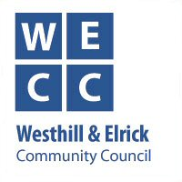
Westhill & Elrick Community Council
12th November Meeting - Key Points Summary

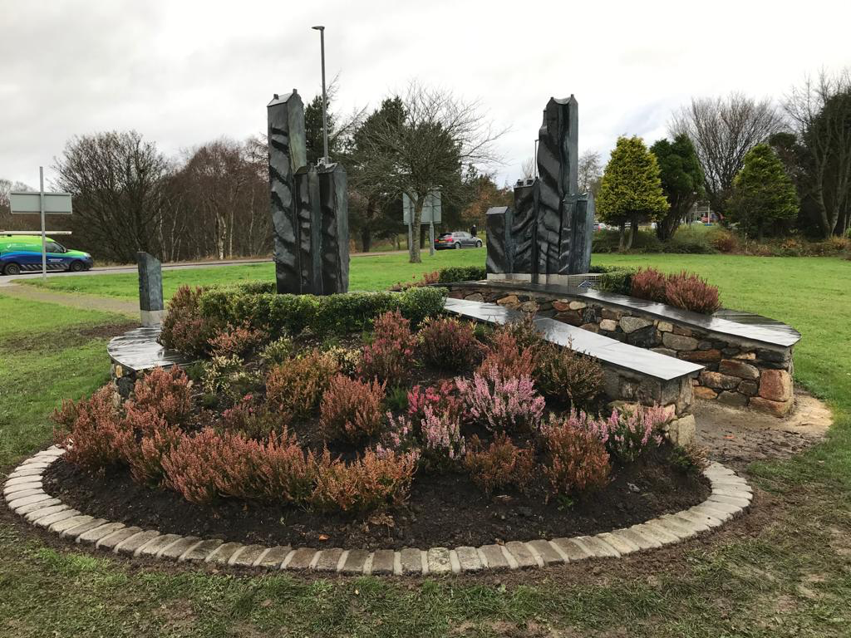
Westhill Gateway Sculpture – Border edging has been completed with granite setts, and a new access path will be laid in late Nov/early December. This additional path, to the East, will link into the Orbital Path. These two activities will put the final touches to the surrounds of the sculpture, thereby bringing it to full completion.

The idea of a piece of art to help identify the town of Westhill, in a way similar to the Alford Bull or the Turra Coo originated about 5 years ago. After public consultation on what they though is the strongest defining characteristic of Westhill, the theme of Community was chosen. After all there is a clear evidence of community life in this area from the Bronze Age onwards. - An artist’s brief was prepared and after careful evaluation a renowned artist Holge Lonze was chosen.

If you haven’t already done so why not pay a visit to see the Sculpture up close and read the Artist’s very informative interpretation board.

Antisocial behaviour – The Police Report for October highlights an approximate 40% increase in anti-social behaviours, particularly by youths. They are taking robust action to identify those involved and various youths have been traced.

Environment – The ponds in Denman Park are silting up and becoming choked with reeds, so we are currently negotiating with the relevant authorities to have them cleaned to restore their appearance and maintain the quality of their habitat for wildlife.

Phoenix Fund/Westhill Westie – plans to promote Westhill as a place to shop and socialise are now underway with a radio advertising campaign. Other campaign elements will soon be introduced. The main themes will be to recognise and celebrate the ongoing efforts of key workers in Westhill; from doctors and nurses, the afore-mentioned police personnel, to late-night shelf-stackers and beyond. Alongside this to help lift the Xmas mood in the midst of ongoing Covid restrictions, we will be running a light-hearted competition (with luxury hampers and cash as prizes) to find Santa’s lost puppy – “Westie”. So please look out for posters and listen out for further radio announcements. Details are also on page 4 of winter Bulletin which will start to be delivered to houses on 28th November

Walk and Cycle Orbital Route – Invitations to tender for the installation of signs and waymarkers have now been issued, and we are hoping to start work in late Jan/early February.

Election of Office Bearers
WECC’s current Office Bearers, who held interim status from March this year were all elected unopposed for another year at the AGM on 12th November.

Road Safety - The dark nights are now upon us and evenings seem to get significantly darker by the day, and this brings increased road safety risks.

Police will be carrying out focused campaigns targetting speeding and anti-social behaviour (sometimes they go together) in towns and villages including Westhill in November and December.

And on a note of Christmas cheer – the Christmas street lights have just been erected, including new lights at the Tesco roundabout, and the Christmas tree will be going up in the shopping centre on 23rd November.

WECC Membership Vacancy - Would you like to get involved in helping improve the quality of life in Westhill?

The Westhill and Elrick Community Council (WECC) exists in large part to maintain and improve the quality of life in Westhill and we currently have vacancy for a co-opted Community Councillor. So we are now inviting self-nominations from interested parties subject to the conditions below* *

If you would like to find out more about what is involved in being a Community Councillor please contact weccchair@gmail.com

Or if you would like to join us please nominate yourself to the WECC Secretary via email to weccsecretx@gmail.com.

Please include your home address and contact details along with a brief statement of why you would like to be a Community Councillor along with a brief indication of what you would like to help WECC achieve for our community of Westhill.

