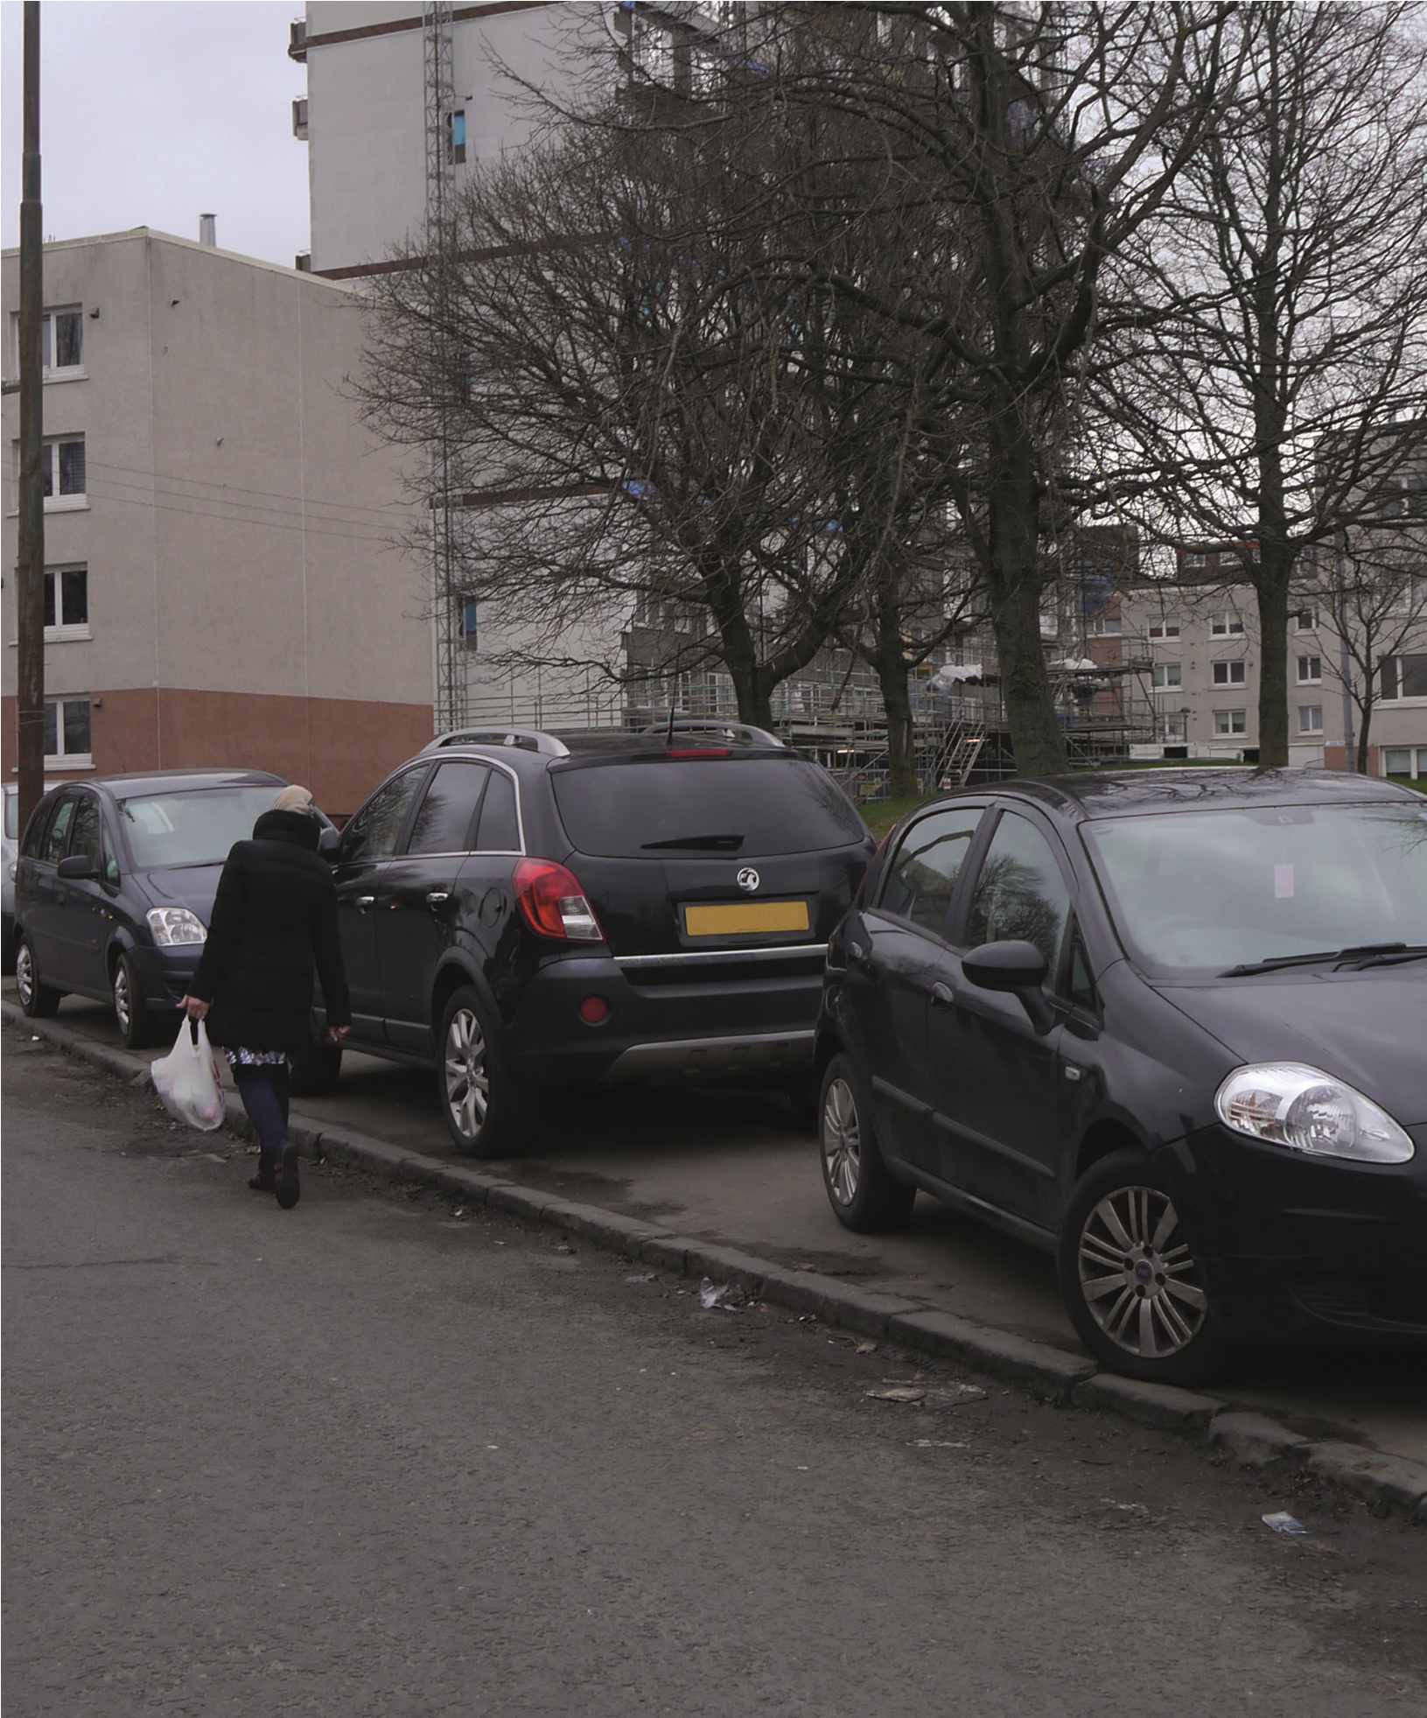
Improving Parking in
Scotland
A Consultation
Parking facilities affect many people and as such, parking
forms an essential part of a local authority’s traffic
management strategy. For disabled people, dedicated
parking spaces provides access to employment, health,
education and leisure opportunities thereby enabling
them to lead independent lives.
What is the problem?
Inconsiderate, obstructive or dangerous parking can cause serious problems – like restricting access for emergency services, or putting pedestrians or motorists in danger by forcing people off pavements and into moving traffic.
What are we doing?
We recognise that the laws on parking are complex and can be confusing. We are therefore undertaking a public consultation to explore how we can improve parking management in Scotland.
A copy of this consultation paper can be found at: bit.ly/consult-parking-imp
What we need your views on
The consultation paper invites views on
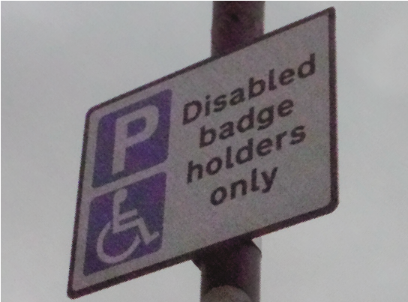
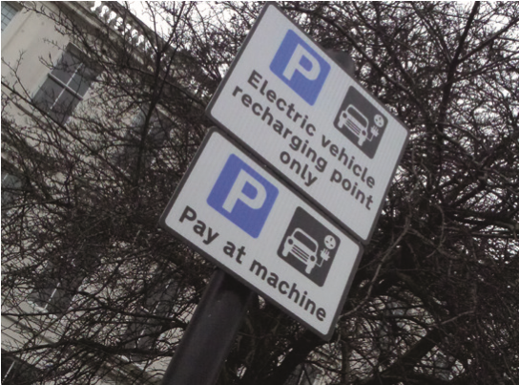
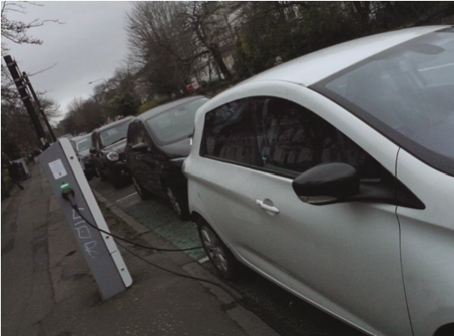
- how we can make parking laws clearer
- what parking restrictions and exemptions should apply
- the best approach for managing parking
- the place for vehicles in today’s town centres, including improved accessibility for all and incorporating new technology.
The closing date for responses is Friday, 30th June 2017.
Please respond to the consultation at http://consult.scotland.gov.uk/
If you are unable to respond online, please complete the Respondent
Information Form and return to: Road Policy Team, Transport Scotland,
8th Floor North, Buchanan House, 58 Port Dundas Road, Glasgow G4 0HF
For questions or to request the consultation in a different format, email parkingconsultation@transport.gov.scot or phone 0141 272 7438.

