Transport Scotland
Parking Consultation
March 2017

ABBREVIATIONS

Automatic Number Plate Recognition ANPR
Business and Regulatory Impact Assessment BRIA
Closed Circuit Television CCTV
Convention of Scottish Local Authorities COSLA
Decriminalised Parking Enforcement DPE
Department for Transport DfT
Disabled Persons’ Parking Places (Scotland) Act 2009 DPPPA
Electric Vehicles EVs
Local Government & Regeneration Committee LG&R
Members of the Scottish Parliament MSPs
Penalty Charge Notices PCNs
Society of Chief Officers for Transportation in Scotland SCOTS
Traffic Regulation Order TRO
Traffic Signs Regulations and General Directions TSRGD
Transport Scotland TS
Ultra-Low Emission Vehicle ULEV

ANNEX A Consultation on improving parking in Scotland

RESPONDENT INFORMATION FORM
Please Note this form must be returned with your response.

Are you responding as an individual or an organisation?

Individual
Organisation

Full name or organisation’s name
Westhill and Elrick Community Council

01224 740669

Phone number

Address
Raymond Swaffield
24 Kinmundy Avenue
Westhill

Community Council Secretary
Becky Ferguson
19 Mains Circle
Westhill

Postcode
AB32 6TG

swaffies@talktalk.net
weccsecretx@gmail.com

Email

The Scottish Government would like your permission to publish your consultation response. Please indicate your publishing preference:
Publish response with name
Publish response only (anonymous)
Do not publish response

We will share your response internally with other Scottish Government policy teams who may be addressing the issues you discuss. They may wish to contact you again in the future, but we require your permission to do so. Are you content for Scottish Government to contact you again in relation to this consultation exercise?
Yes
No

CONSULTATION QUESTIONS
General

Q 1. Do you think parking, including on pavement, at dropped kerbs and double parking is a problem in your area?

- If yes, how have you, your family or friends been affected by parking problems?
- Where did this occur (e.g. type of street or area) and how often?
I am a Community Councillor. As a disabled person, I have been requested by my Community Council to represent them in this consultation, as I am well aware of the problems such parking can cause disabled as well as able bodied people.

Yes. In the last few weeks, I have had to make outside journeys in my wheelchair. There are regularly cars parked on the pavements on the streets around my home, which is a suburban residential area. I have been affected by this weekly. Some vehicles park such that even on foot it is necessary to go out onto the road to pass. When in my wheelchair, the problem is more serious. Negotiating kerbs in a wheelchair is fraught with problems and can be very painful for some disabilities. The requirement to undergo this, perhaps several times in a street because of blocked pavements is something that this legislation would tackle.

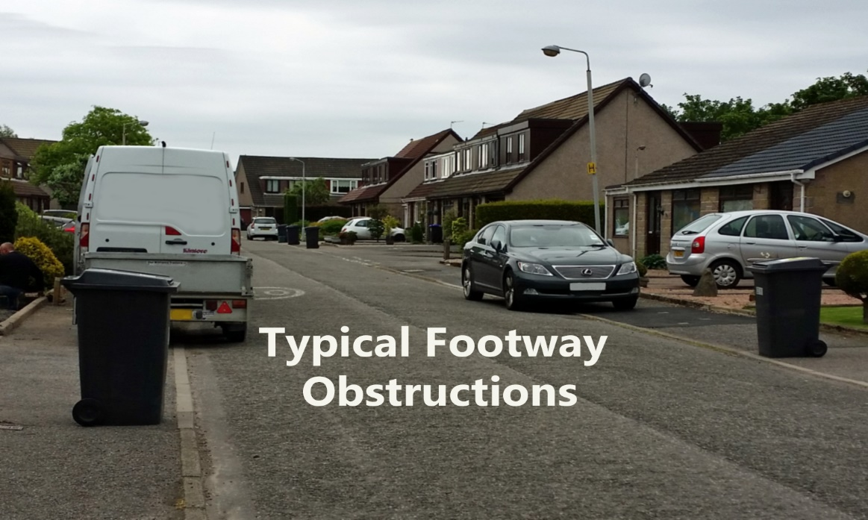
Legislation

Q 2. Why do you think the motorists may choose to pavement park?

Motorists find it easier to simply mount the pavement rather than accurately park close to a kerb. They also feel their car may be safer from bumps from passing cars and they may want to avoid causing any obstruction for passing traffic.

Q 3. Do you think new legislation is needed?

- If yes, what areas of the law need to be amended?

Yes. It is ludicrous that the current law permits pavement parking but bans driving onto the pavement. These two actions need to be considered together in order to simplify enforcement. The Law should be based on the aims set out on the Footway Parking and Double Parking (Scotland) Bill. The Greater London ban on footway parking seems to clearly identify conditions that pavement parking could be justified and would be a good model to incorporate into new legislation.

Q 4. If a new law is required, should it cover all roads with footways, including private roads that are not adopted by local authorities and trunk roads?

- If not, why not?

Yes, but exceptions could be created for areas where special conditions can be identified and justified. A universal law for all areas greatly simplifies the need for special signage and removes the requirement for local knowledge of differing restrictions. This should not make trunk road parking more acceptable though.

Q 5. Do you think any new law should apply to all vehicles (e.g. HGVs, vans, taxis, cars, motorbikes, etc.)?

- If not, which type of vehicles should the law not apply to?

I can see no reason to blanket exclude any particular group of vehicles. However there can be circumstances where any vehicle could have good reason to pavement park or block lowered kerbs for a short period. e.g. Cars allowing disabled passengers to enter or exit.

Q 6. Do you think there should be exemptions applied to allow pavement parking to take place, particularly due to local concerns about access for vehicles and lack of alternative parking provision?

- If yes, what should those exemptions be?
- If no, why not? (Please be as specific as possible)

Exemptions should be granted for emergency service vehicles. Also, short time limited stops for delivery vehicles dropping off individual parcels and vehicles collecting or delivering disabled people where otherwise they could not get close to the target building.

Implementation & Enforcement

Q 7. Should there be consistent approach to parking enforcement across Scotland?

- If yes, how should this be taken forward?

Definitely. Scottish Parliament need to instruct local authorities to enact the legislation and enforcement methods decided in a new law. DPE powers should rolled out throughout Scotland. A criminal record for offenders of these types of offence is not desirable and unlikely to reduce offending.

Q 8. Local authorities in some parts of Scotland have DPE powers and are responsible for parking enforcement. In other areas Police Scotland retains responsibility.

- What is your views on rolling out Decriminalised Parking Enforcement regimes across Scotland?
- What is your views about the proposal to share services to provide some access to a “traffic warden service” in areas without DPE?
- What should Police Scotland’s involvement be in future?

It seems obvious that this is an ideal solution and could be made to work well with adjacent areas that have a smaller need for parking enforcement issues, enabling sharing of costs.
Police Scotland should be left to patrol other criminal activities and only be involved in parking concerns where wardens were faced with aggressive or dangerous situations or disputes.

Q 9. Currently moving traffic violations are a matter for the police, however, do you think local authorities should be able use CCTV and/or Automatic Number Plate Recognition (ANPR) systems for enforcement of:

- parking in areas where safety benefits can be delivered to all road users, around schools for example?
- Some moving vehicle contraventions like banned turns?
- If not, why not? (Please be as specific as possible)
This seems to be a logical extension to local authority powers. Unsafe parking around schools is a universal problem and such a power would undoubtedly deter the offenders and probably improve the health of parents and children by increasing exercise as well as improving safety. ANPR cameras are expensive but if they were able to produce a mobile version, able to be easily moved from place to place the justification in cost would be more acceptable and would certainly be effective. Some authorities already use DPE powers, as on bus lane control. Information available from Aberdeen suggests that this scheme is more than self-financing. It would be important to ensure that some form of appeal mechanism is in place for offenders who feel they have been unjustly fined. I would not be in favour of using CCTV to fine offenders. CCTV could more acceptably be used to guide wardens to problem parking areas.

Traffic Regulation Orders (TROs)

Q 10. Do you think it is a good idea in principle to allow local authorities to exempt specific streets or areas from national restrictions for pavement parking?

- If so, what is the best mechanism for doing this (e.g. TRO or other form of local resolution)?
Local authorities will definitely require identifying areas that require exemptions, possibly only for special occasions like market days etc. Other more permanent exemptions could be set out in sub sections described in the national legislation as e.g. the Greater London ban on footway parking rules.

Displacement of vehicles

Q 11. Do you think controlling pavement, dropped kerbs and double parking could have unintended or negative consequences in your area?

- If so, what would the effects be?
- Who would be affected?
- What type of street or area would experience these consequences?

If streets are narrow but traditionally have cars parked on both sides using the footways, then new rules may remove many parking spaces. Residents in such areas will be faced with finding new places to park. This would be a more serious problem for disabled drivers. On the positive side, motorised wheelchair users and pram or buggy pushers will find progress much easier and it may slow the traffic and so improve safety.
Drivers may be forced to park farther away from home and possibly annoy residents in other areas by taking their spaces. In my local area, there is often space in driveways that aren't used, while cars are pavement parked outside. Perhaps some education from local authorities highlighting the difficulties pavement parking creates, and encouraging people to make space in driveways for visitors if possible, could help encourage drivers to be more considerate.

Town Centre Regeneration

Q 12. Do you think controls on parking are likely to increase or reduce the costs and impact on businesses in town centres?

- If yes, what should we be doing to reduce any impact on businesses in town centres?
- What other arrangements should be considered to deliver parking improvements that help support town centre regeneration?

It is important to offer reasonably priced parking near town centres. Where this is impactable because of available space, reliable and reasonably priced out of town Park and Ride systems can offer access to towns and reduce air pollution and congestion. Fewer vehicle movements in town centres will make pedestrian experience more attractive and may encourage more interest in visiting town centre businesses.

Disabled Parking Bays

Q 13. Do you think that on-street disabled persons’ parking places are being enforced in your area?

- If not, how could this be done better?
- Do you think members of the public should report misuse where it is observed?

There is very little evidence of such enforcement in my area. There are very few on street bays but many in public car parks. I have seen little evidence of abuse in school, library and swimming pool bays, but regular abuse in shop and supermarket bays. I feel that the small number of street bays in our surrounding area need very little enforcement at present times but could very easily be covered by wardens policing car park bays. Public reporting of misuse should be welcomed but unlikely to be done by other than disabled persons at the moment.

Q 14. Have you witnessed misuse of a disabled persons’ parking space?

- If so, did you report it?
- If not, did anything prevent you from reporting it?
- Should disabled persons’ parking places be enforceable at all times?
- Do you think the level of penalty for misuse of local authority disabled persons’ parking space is acceptable?
- If not, what level would you consider to be acceptable?

I regularly witness misuse in shopping car parks. I have very occasionally tackled drivers when I see them walking from a bay and have always been met with verbal abuse. This has resulted in a strong disincentive from repeating the experience.
I have never reported the misuse to any authority as it has been unclear as to who to consult and also the culprit is likely to be gone by the time any action could be taken. The penalty level is probably adequate. How to report such offences should be adequately advertised as currently there is only vague knowledge of how to go about this.

Q 15. Do you think off-street disabled persons’ parking spaces, including private car parks, are being enforced in your area?

- If not, how could this be done better?

Not at all. These are the areas where offending is most common. In areas that have obtained DPE powers, a traffic warden service will have been set up. They will enforce street and local authority parking. It seems clear that these wardens should also patrol the private off-road parks. This will require negotiation with the owners but such controls are likely to be less unpopular than with private wardens, who are often seen to be working for companies solely to maximise profits. Looking to the future, a possible option could be that a condition of planning permission for new premises with public car parking, such as shopping centres, could be a requirement to give local wardens powers of enforcement within their car park.

Q 16. What impact do you think disabled persons’ parking space misuse has on Blue Badge holders?

Depending on the severity of the disability, it can, in extreme cases, cause the person to abandon their intended visit. The longer the distance a disabled person has to travel to an entrance door can increase pain or discomfort proportionately. Many people do not appreciate that many disabled drivers require the car door to open much wider than for the abled bodied, in order to get out or in again. This fact is taken into account in most disabled bays by increasing the bay width. Many normal bays are so narrow that it can be very difficult or painful for disabled drivers to attempt to use them. Wide bays are essential for Wheelchair users. The non-availability of a wide bay for such users has serious implications.

Emissions Vehicles

Q 17. Are you supportive of local authorities’ trialling or introducing parking incentives (such as discounted, free or preferential parking) for ULEVs?

- If yes, what should these incentives be?
- If no, why not?

ULEV’s are certainly something we should be encouraging, but I would presume that gradually most vehicles will fit this pattern in the future. I see little value in creating special parking facilities for them, other than for the charging points, as this would create further public disquiet from normal vehicle owners feeling disadvantaged and who may only able to afford older less clean vehicles. Ultimately, these special bays would have to be phased out again.

Q 18. Are you supportive of local authorities trialling or introducing specific measures to help people who, live in flats or tenements (with no dedicated-off street parking) charge their vehicles?

- If yes, what should these incentives be?
- If not, why not?

This seems a very hypothetical question as there is likely to be no available land close to this type of city housing. Surely anyone moving into such property should appreciate that car ownership would be problematic in that area. A more sensible approach is for Local Authorities to ensure there is adequate and reasonably priced public transport available. For occasions that a car is desired by occupants in these areas, the use of a car club vehicles are an option and could be considered.

Q 19. Do you think the use of ULEV-only charging bays should be monitored and enforced by local authorities?

- If yes, please say why.
- If no, how should they be enforced and who should be responsible for this enforcement?

Yes. This would help ensure EV’s have good access to charging points which could otherwise be blocked by conventional cars. There is a limited supply of these points and they are an incentive towards ULEV ownership and essential for longer journeys. The enforcement should be carried out by the wardens who also enforce street parking etc. in the area.

Assessing Impact

Q 20. Are there any likely impacts the proposals contained within this consultation may have on particular groups of people, with reference to the ‘protected characteristics’ listed above? Please be as specific as possible.

I cannot see why any of the list of groups should be more impacted than they may be with existing legislation. People with certain forms of disability currently suffer abuse for using disabled bays legitimately, when the nature of their disability is not immediately evident.

Q 21. Apart from safety, are there any other aspects of a child’s rights or wellbeing that you think might be affected either positively or negatively by the proposals covered in this consultation?

The enforcement of parking restrictions near schools should encourage more walking and so improve the child’s health. A safer and less polluted walk to school could enable children to develop better road sense at a younger age than if they are always dropped off from a car.

Q 22. Do you think the proposals contained in this consultation are likely to increase or reduce the costs and burdens placed on any sector? Please be as specific as possible.

Local authorities will inevitably face increased costs initially from the set up and establishment of TRO’s and with negotiating powers with private businesses. They would have on going costs for the employment of Wardens but these costs could be offset from the collection of PCN’s. The Police force would have reduced costs as they would no longer be involved in this field of work. Businesses would be unlikely to face more costs if enforcement of their parking was undertaken by local authority wardens.

Q 23. Are there any likely impacts the proposals contained in this consultation may have upon the privacy of individuals? Please be as specific as possible.

There should be no need for Privacy intrusion of individuals to be involved in setting up this legislation. Applicants for blue badges will continue to have to explain personal issues in the application form and possible medical examination but other groups will not be involved. If special incentive facilities were to be introduced for ULEV owners this could possibly require owners to make declarations to obtain some form of permit.

Q 24. Are there any likely impacts the proposals contained in this consultation may have upon the environment? Please be as specific as possible.

Street parking enforcement that reduces street width is likely to reduce vehicle speeds. This can actually increase exhaust pollution but less than is created by speed bumps do in attempting to have the same result. Less parking places in any area may cause cars to drive around further in attempting to find a space.

Conclusion

Q 25. Do you have any other comments that you would like to make, relevant to the subject of this consultation that you have not covered in your answers to the previous questions?
I suspect that many drivers will object to this proposed legislation as an imposition on their freedoms. However, footpath users will have a totally different view and will welcome and appreciate the improvement in safety and convenience. Blue Badge holders have long desired proper enforcement of parking bays. I would hope that adverse reactions would gradually die down, with an acceptance of the improved conditions for all. With an increasingly aged population, these measures will be of greater benefit and should be introduced without delay. Most of the groundwork has already been undertaken for the Greater London Scheme 1974 and the Footway Parking and Double Parking (Scotland) Bill 2015. These Bills could certainly form the basis of new legislation and avoid much duplication in prior research for new legislation.

