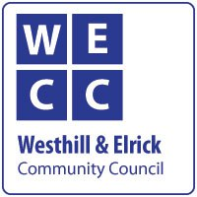

WESTHILL & ELRICK COMMUNITY COUNCIL WILL BE HOSTING A
PUBLIC MEETING
REGARDING THE
PROPOSED KINGSFORD STADIUM DEVELOPMENT
ON TUESDAY NOVEMBER 1ST
7PM, BALMORAL SUITE, HOLIDAY INN WESTHILL
ALL WELCOME
PLEASE DO COME ALONG TO DISCUSS THE PROPOSAL
