Actively supports the local community - “by helping people to help themselves”

Liaises with Aberdeenshire Council, Police Scotland and other partners regarding community planning.
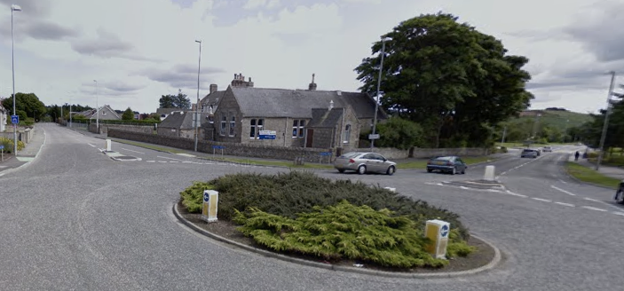
- We are consulted on planning issues and where necessary
act on them.
- We also respond to local and
national government consultations.

Organises community events – Easter “Eggstravaganza”


Organises bulb planting, hanging baskets, Christmas lights, local Christmas tree and local litter picks.


Donates funds to local community groups to help them develop.

Networks with local groups and charities

Protects and promotes quality of life for Westhill and Elrick Communities

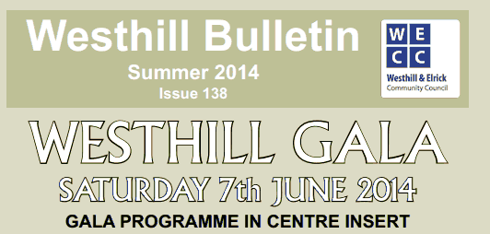
Produces and distributes the excellent Westhill Bulletin.

Supports Public Art

Holds public, monthly meetings to discuss local issues and seek solutions.

EVER THOUGHT OF JOINING US?
CALL BY FOR A CHAT AT OUR STALL TODAY

OR
Get more info @ www.westhillelrick.org name
Facebook – Westhill and Elrick Community Council (full title req.)

