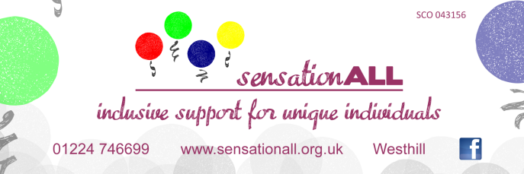
PRE-SCHOOL SERVICES / GROUPS – Tues / Thurs
(These groups will run up until end of June 2016 – then we will be running our Summer Programme groups – see separate info – until these groups will re-commence week beginning 15th August 2016.)
Sing, Move, Play, Learn (SENSE Group)
Tuesday mornings (10:30 am - 12:00 noon)
@ Lawsondale Sports Pavilion (off Arnhall Crescent) Westhill AB32 6TY

Led by Gwen Auchterlonie (SENSE Scotland) & SensationALL Staff

SensationALL are working in partnership with SENSE Scotland, to provide a semi-structured, non-judgmental support group to families with children who have complex communication and support needs, early in their development who benefit from slow paced activities and low-stimulating environment. Experienced staff, engaging children through music, movement, play & sensory activities, this group promotes early interaction skills, play and learning with a sensory focus. As a parent / carer, you gain the added benefit of meeting other families in similar situations, whilst picking up useful signposting information and an added confidence that your child is in a safe, suitably stimulated environment.

Fees: £5 per session (first child); £2.50 per session (for second child) - payment by session upon arrival or by block term
SIBLINGS WELCOME.
Booking essential by emailing Karen@sensationall.org.uk

We also run a group for our older / more active Pre-Schoolers on a Tuesday afternoon from 1:30 - 3:00 pm @ Lawsondale. Details are below:

Active Pre-School Play
Tuesday afternoons (1:30 pm - 3:00 pm)
@ Lawsondale Sports Pavilion

Supported by SensationALL Staff

Come along with your child or children with support needs for unstructured play sessions, where you can enjoy an open, informal, non-judgmental group with access to small soft-play equipment and our sensory room. Experienced staff facilitate activities, promoting early interaction skills and learning.

Fees: £5 per session (first child); £2.50 per session (for second child) - payment by session upon arrival or by block term
SIBLINGS WELCOME.
Booking essential by emailing Karen@sensationall.org.uk

CONTINUED ON NEXT PAGE

And also, we are currently running an Early Communication Skills Group on Thursdays (for 8 weeks) at the Old School House in Westhill.

Early Communication Skills Group
Thursday mornings (10:00 - 11:00 am)
@ Old School House – 1 Westhill Road, Westhill - AB32 6FT

Led by Kathy Sherrit & Lara Goldie (Speech & Language Therapists) & supported by SensationALL Staff

This new, unique 8-week group helps parents & carers learn to support and encourage the development of early communication skills through play. The sessions include group instruction, time to practice newly learned skills with individual coaching & feedback from the therapists, and an opportunity to ask questions. Class will include professional instruction, fun activities for the children, and the opportunity to meet with and learn from other families. We aim to provide the knowledge, skills & confidence that parents & carers need to support communication abilities of children with multiple support needs.
Fees: £40 payment for the 8-week programme (payable upon booking)
SIBLINGS WELCOME
Booking essential by emailing Karen@sensationall.org.uk

NOTE: This group will run from 5th May – 23rd June.

OTHER SERVICES / GROUPS
Tea & Tips Drop-in Advice (Informal Consultations with Qualified Staff)
Fortnightly on Wednesday afternoons (BY APPOINTMENT ONLY)
@ Old School House – 1 Westhill Road, Westhill – AB32 6FT

Got some questions about your child or young person’s condition, learning or behaviour?
If you’re looking for some guidance regarding toilet, sleep training, or introducing practical strategies, then come along and discuss your concerns with our highly experienced therapy staff. This is an open, drop-in session where you will have an opportunity to access decades of specialised experience with our staff. This is mainly for parents, as play facilities are not available on-site for this day/time. BOOKING IS ESSENTIAL.
Phone discussions can be arranged if not available to attend, but fees still apply.
Fees: £10 per hour (payable upon booking / upon arrival)
Aimed at parents / carers of individuals with MSNs.

Stay & Play Family Sessions
Sunday afternoons (as arranged / often fortnightly)
NEW DATES / TIMES AVAILABLE – see attached details
1 – 2 pm / 2 – 3 pm / 3 – 4 pm sessions
@ Lawsondale Sports Pavilion (off Arnhall Crescent) – Westhill – AB32 6TY

Informal free-play sessions for families with youngsters who have MSNs, siblings also welcome! Come and meet up with other families during these sessions, which are led by experienced staff and supported by volunteers. This is a fantastic opportunity to meet other families in similar situations, where you will feel confident of your child being in a safe, suitably stimulated environment and spend time together in our sensory room. BOOKING IS ESSENTIAL!
Fees: £5 per child, per hour (£12 max per family)

SensationALL Singers – Inclusive Choir
Wednesdays (6:30 – 7:45 pm)
@ Old School House – 1 Westhill Road, Westhill – AB32 6FT

An informal inclusive group of individuals with MSNs, their families and other local members of the community sharing an interest in singing. Percussions, small instruments and basic sign language are often incorporated, led by a music specialist and experienced SensationALL staff. The group actively influence the song choices which (with a wide range of ages) are very varied.
FREE & OPEN TO EVERYONE
No booking necessary

