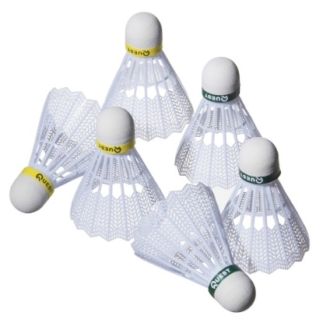
BADMINTON
The coaches give children of P4 and above the chance to learn an enjoyable life-long skill playing Badminton. Cost £3.40 per class paid in a block. Beginners Mondays 6-7 pm,

Improvers Tuesdays 6-7 pm, Proficient Tuesdays 7-8 pm,

Saturday (all levels) 10.30 – 11.30 am
FITSTARS
P1-3 come to this group to have fun and exercise through story-telling and imaginary play. Cost £3.40 per class paid in a block. Mondays 6.15-7.15 pm


COOKING

P6 and above come along and make both sweet and savoury dishes. A totally enjoyable experience for all. Cost £5.90 per class paid in a block.

Tuesdays 4.30 – 5.45pm

BAKING
Come along and try baking an assortment of cakes and biscuits. What better way to finish off the day than with your own home bakes? Cost £5.90 per class paid in a block. P6 and above. Wednesdays 4.30-5.45pm

DANZE
P1 onwards learn different dances to great music on Wednesdays. Each year these children get the opportunity to perform in front of an audience at their own show. Cost £2.80 per class paid in a block. Wednesdays: Beginners 1 6.15 – 7.00pm, Beginners 2 7.00 – 7.45pm, Improvers 7.00 – 7.45pm

FOOTBALL
Football coaching for boys and girls in P1 and 2. If you enjoy football then you will love this. Cost £3.40 per class paid in a block. Tuesdays P1 & P2 6pm -7pm, Wednesdays P1 6 -7pm, P2 7-8 pm

SATURDAY DRAWING AND PAINTING
P4+ take part in drawing and painting animals and other subjects on a large scale using a variety of materials. A popular art class. Cost £6.35 per class paid in a block. Saturday morning 10 am-12 noon
SATURDAY DANCE
Boys and girls of P1 and above can come along and learn how to do dance routines. At the end of the year the children get together with the Wednesday Danze group and have the opportunity to impress their parents with their end of year performance. Cost £2.80 per class paid in a block. 9.15-10.00 am or 10.00-10.45 am,
WEDNESDAY ART
P4 upwards, learn different techniques in drawing and painting. This class has been very popular with children staying term after term. Cost £6.35 per class paid in a block. Wednesdays 4.00- 6.00pm
To enrol or for further details contact


Westhill Community Centre, Hays Way, Westhill
Tel 01224 740089
Email westhill.cec@aberdeenshire.gov.uk

