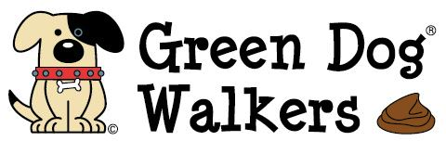

What is Green Dog Walkers?
Green Dog Walkers (GDW) is a non-confrontational, friendly way to change attitudes about dog fouling in the Aberdeenshire area.

Volunteers wear an item of GDW merchandise ( versatoob , lanyard, badge), or their dogs wear the smart green GDW collar to show they have "taken the pledge" to always:
- Clean up after their dog
- Carry extra dog waste bags
- Be happy to be approached to 'lend' a dog waste bag to those without
- Be a friendly reminder to other dog walkers to clean up after their dogs

Become a Green Dog Walker (GDW)

To become a Green Dog Walker, sign and return a GDW pledge form** to the address below, and you will be provided with your chosen item of GDW merchandise, free poop bags and a membership card allowing you to collect further dog waste bags from Westhill Service Centre as you need them:

email : Greendogwalkers@ aberdeenshire.gov.uk

or telephone:

Dog Warden (Central)
Aberdeenshire Council
Environmental Health
Gordon House
Blackhall Road
Inverurie
AB51 3WA
Telephone: 01467 628195

** Available from the Westhill Service Point at Westhill Library

or download it from

https://www.aberdeenshire.gov.uk/animals/dogs/GreenDogWalker.asp

